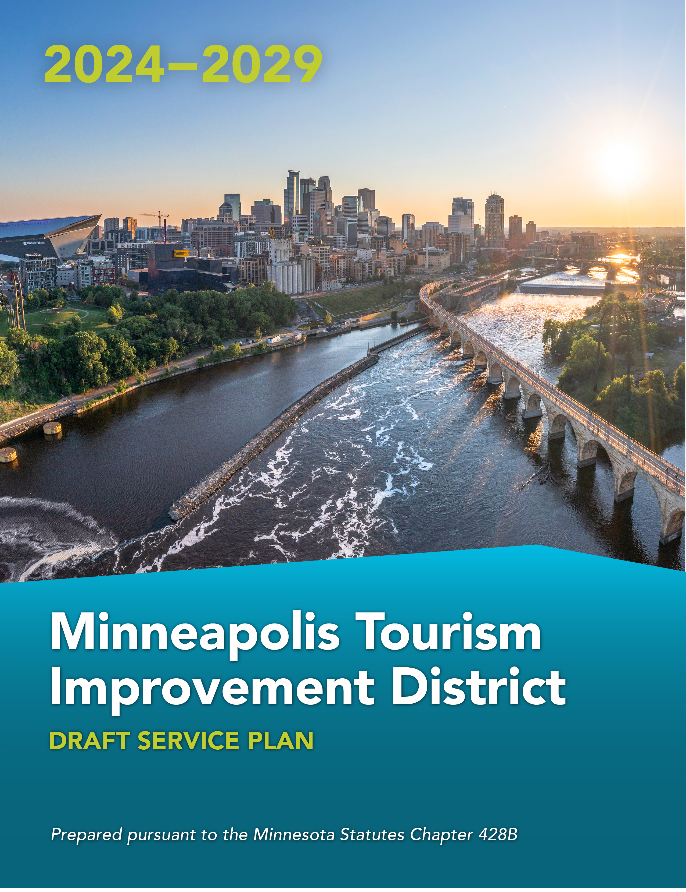
2024-202

Minneapolis Tourism Improvement District (MTID)

Draft Service Plan

PURPOSE
Developed by Minneapolis lodging businesses with more than fifty (50) rooms and Meet Minneapolis, the Minneapolis Tourism Improvement District (MTID) is a special services district proposed to provide the benefit of additional room night sales directly to payors, by funding sales and marketing programs for MTID lodging businesses. This approach has been used successfully in other destination areas throughout the country.

BOUNDARIES
The map below illustrates the proposed MTID boundary. The proposed MTID includes all lodging businesses, existing and in the future, with more than fifty (50) rooms available for lodging within Minneapolis city limits. A full list of lodging businesses can be found in Appendix 1.
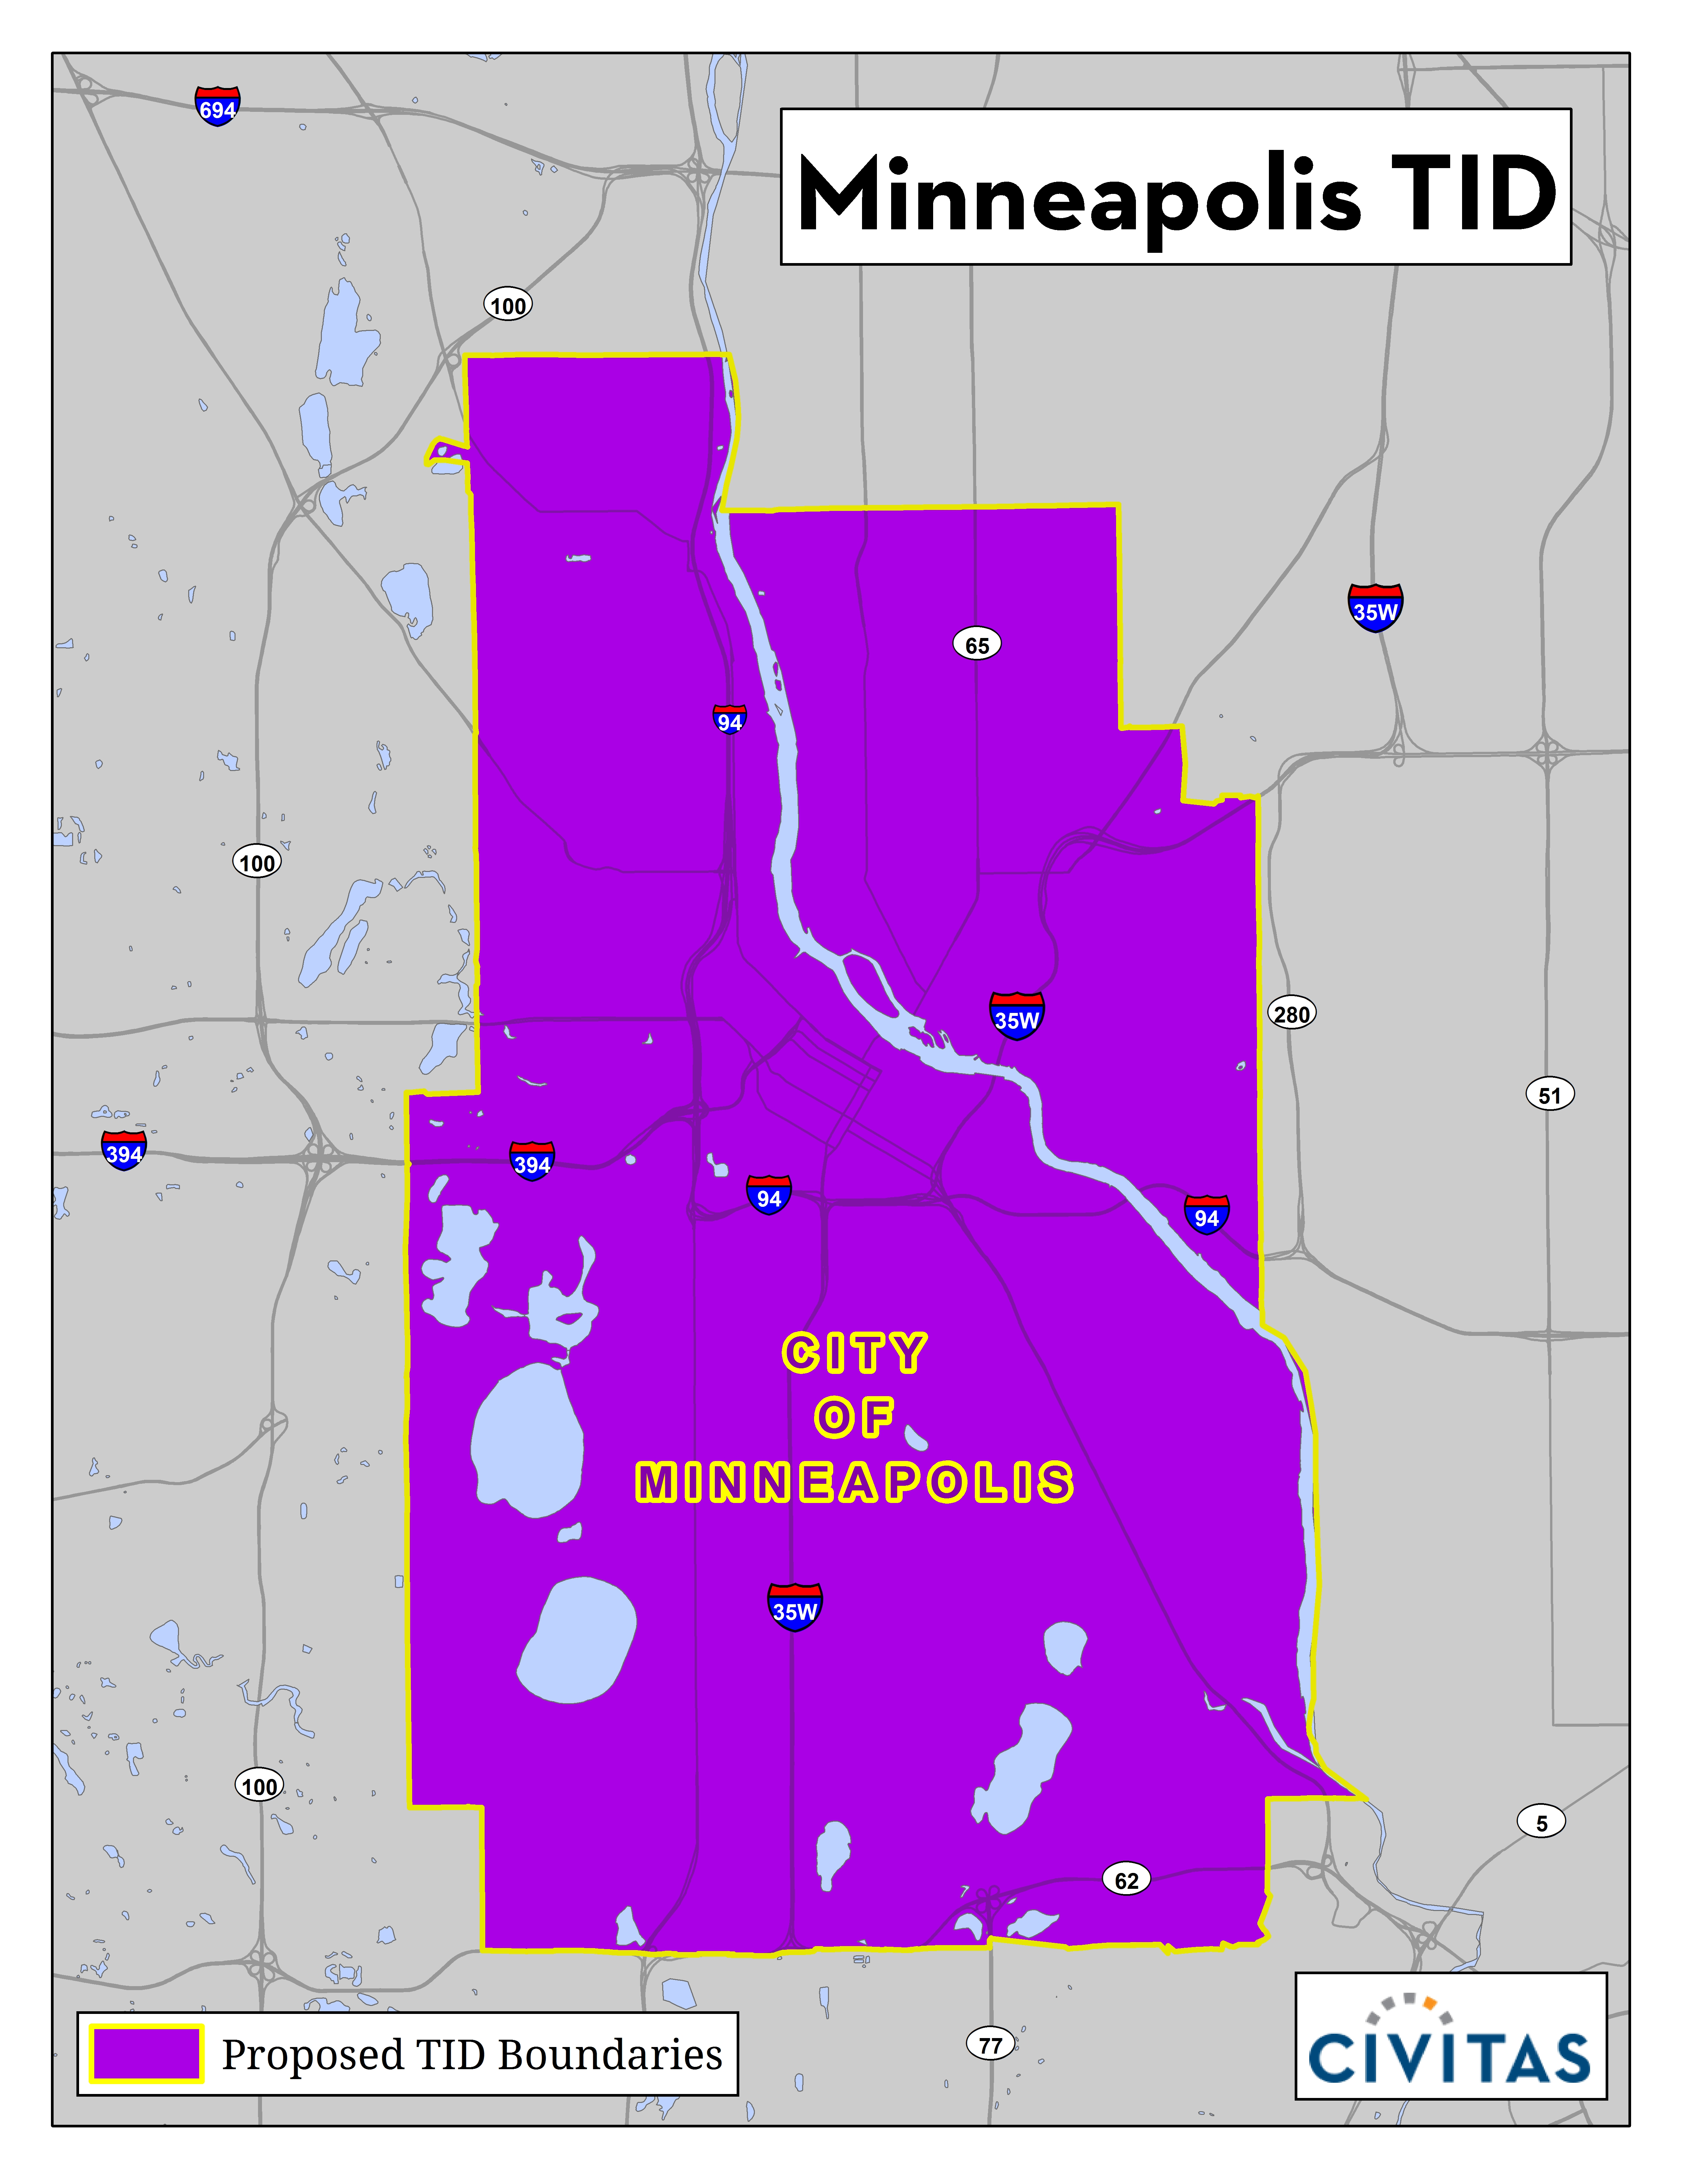

SERVICE CHARGE
The proposed service charge is 2.0% of gross short-term room rental revenue. The service charge shall not be applied to: room rentals of more than thirty (30) days; room rentals where there is a written rental agreement requiring the customer or owner to give notice before ending the rental; or separate charges for taxable lodging related services associated with the room rental (pay per view movies, video games, room service, etc.), and stays pursuant to contracts executed prior to October 1, 2024.

PROJECTED COSTS

For example, assuming collections of $6M the MTID budget will be allocated as shown in the table below.

SERVICES | % | $
Marketing / PR | 30% | 1,800,000
Special Projects / Activation | 25% | 1,500,000
Sales | 35% | 2,100,000
Administration/Collections | 5% | 300,000
Contingency / Reserve | 5% | 300,000
TOTAL | 100% | $6,000,000

The MTID Committee shall have the authority to adjust budget allocations between the categories by no more than fifteen percent (15%) of the total budget per year.

PROPOSED ACTIVITIES AND IMPROVEMENTS

MTID activities and improvements are intended to supplement, not supplant, existing City-funded services - Section 8 of the Law states that municipalities may impose service charges to finance activities or improvements that are at an increased level of service. Services may include the following activities and improvements:

Marketing / PR

A marketing and public relations program with a central theme of promoting the destination as a desirable place for overnight visits. The program will have the goal of increasing demand for overnight visitation and room night sales at assessed businesses and may include the following activities:
- Engage Public Relations firm to support travel messaging, including familiarization trips and media hosting to promote assessed businesses;
- Develop integrated marketing and communications campaign(s) to promote overnight visitation to assessed businesses;
- Online marketing efforts, including social media to increase awareness and optimize internet presence to drive overnight visitation and room sales to assessed businesses;
- Preparation and production of print and online collateral promotional materials to promote the destination such as brochures, visitor guides, flyers and maps featuring assessed businesses;
- Attendance at and hosting of professional industry conferences and affiliation events to promote assessed businesses;
- Partnership with both local and state tourism organizations to target key domestic and international markets to increase overnight visitation at assessed businesses;
- Programs focused on branding of the destination to ensure a consistent brand experience and increase demand for overnight visitation at assessed businesses;
- Development of Return on Investment (ROI) analysis of district funds and increase demand for overnight visitation at assessed businesses; and
- Activities designed to support the above efforts through consumer research, market intelligence and opportunities to increase awareness and demand for overnight stays at assessed lodging businesses.

Special Projects / Activation

A Special Projects and activation program will be utilized to sponsor and/or create special events or activations designed to attract overnight visitors to assessed businesses, and may include the following activities:
- Create experiences to drive leisure room nights to the destination during need periods to assessed businesses;
- Support multi day experiences that would support increased demand for assessed businesses;
- Sustainability programs that offset impacts of tourist visitation within the destination;
- Business support and advocacy activities designed to strengthen the local economy by gathering and analyzing economic data, providing information on opportunities and resources, supporting new business development, and advocating for policies that would support the hospitality industry and on behalf of the assessed businesses; and
- Workforce development activities that position the local hospitality industry as an attractive career option, which may include workforce development strategies, research and/or programs deployed to improve the visitor experience and increase demand for overnight visitation and room sales to assessed businesses.

Sales

A Sales program will be designed to support site selection and attendee room night production. The sales program can also be used to supplement trade show attendance and create signature events in key markets to promote the destination. The sales program may include the following activities:
- Customer familiarization tours for targeted convention, meeting, event, and travel decision makers to promote assessed businesses;
- Incentivizing conferences and meetings to book at the destination to increase overnight visitation at assessed businesses;
- Participation in or hosting of trades shows and meetings-focused appointment events to engage directly with meeting planners and generate leads for assessed businesses;
- Maximizing alliances with professional organizations that target group business, or database services that track group opportunities to develop new leads for assessed businesses;
- Develop and execute Minneapolis signature experiences for the purpose of new domestic and international market development to generate new leads for assessed businesses; and
- Target campaigns for meetings market retention from state and regional corporations and associations to generate leads for assessed businesses.

Administration
The administrative and operations portion of the budget shall be utilized for administrative staffing costs, office costs, and other general administrative costs such as insurance, legal, and accounting fees.

Contingency / Reserve
The budget includes a contingency line item to account for uncollected assessments, if any. If there are contingency funds collected, they may be held in a reserve fund or utilized for other programs, administration, or renewal costs at the discretion of the Tourism Improvement Association. Policies relating to contributions to the reserve fund, the target amount of the reserve fund, and expenditure of monies from the reserve fund shall be set by the MTID Committee. Contingency/reserve funds may be spent on TID programs or administrative and renewal costs in such proportions as determined by the Tourism Improvement Association. The reserve fund may be used for the costs of renewing the MTID.

Collection Fee
The City of Minneapolis or a third party shall retain a fee up to five percent (5%) of the amount of assessments collected, to cover collection and administration costs.

MANAGEMENT

The MTID will be managed by a nine (9) member TID Governance Committee comprised solely of hotel owners/representatives paying the MTID service charge. The TID Governance Committee shall have full authority to manage matters related to the MTID on behalf of the MTID members including, but not limited to, authorization for use of MTID funds and decision-making authority regarding MTID programs in accordance with this service plan. The TID Governance Committee shall be chartered as a standing committee of the Meet Minneapolis Board of Directors and represented by appointment.

COLLECTION

The City of Minneapolis or a third party will be responsible for collecting the MTID service charge on a monthly basis (including any delinquencies, penalties and interest) from each hotel property located in the MTID boundaries, and the City of Minneapolis or a third party will be reimbursed from MTID funds for its actual costs for this activity.

TERM
The MTID will be formed for a five (5) year period, with services projected to commence October 1, 2024, or as soon as possible thereafter. After five (5) years, the MTID may be renewed if lodging business owners support continuing the District.

